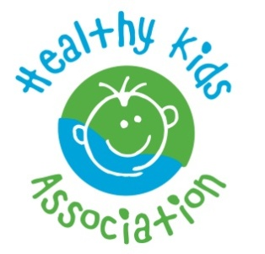
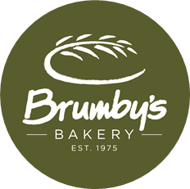
Brumby’s Strathmore
Australia & New Zealand Store of the Year

3 Lloyd St, Strathmore 3041
PO box 545 Essendon North 3041
Ph. 03 93790056 Mob: 0413 414 774
Email: brumbysstrathmore@hotmail.com
ABN 55356246069

Here’s a Super FUNdraising Idea that is sure to get the taste buds watering!

Brumby's Strathmore is proudly the No. 1 Hot Cross Bun Brumby's store in Australia and have a long association the local community schools and kinder, assisting with fundraising for over a decade.
Brumby’s Strathmore is making it easy for us this Easter with their delicious Hot Cross Bun fundraiser. Baked fresh daily, onsite, by family-owned bakers with 100% Aussie Wheat, Brumby’s traditional, fruitless, Cadbury Chocolate and our exclusive Nutella variety hot cross buns are the highest quality baked Easter products on the market!

BRUMBY'S STRATHMORE EXCLUSIVE OFFER:
For every 6 Pack of Hot Cross Buns you purchase for $7.50:
- We receive: A MASSIVE 46% profit!
- $2.00 profit for every 6 pack sold
- 10% store credit because at Brumby's Strathmore know important fundraising is.

46% PROFIT FOR THE SCHOOL IS GREAT! BUT WHAT'S IN IT FOR ME?
For every 6 Pack purchased for $7.50, you receive an incredible 44% off RRP:
- $13.30 value for only $7.50! That’s a saving 44% off RRP!
- $7.50 for 6pk is 17% LESS than the RRP instore!
- Plus YOU get One FREE sandwich loaf or 6 Rolls voucher with EVERY 6 pack purchased
(EG. Buy 2 packs - Get 2 x FREE loaf / 6 rolls vouchers)
- Free sandwich loaf/ 6 rolls voucher redeemable ANY DAY, ANY TIME, when it suits.
- Stagger your free voucher redemptions, over the long validity period, providing great value.
- Free sandwich loaf / rolls can be White, Wholemeal or Multigrain, are made with 100% Aussie wheat and are preservative free ensuring healthy choices and approved by the Healthy Kids Association.
- You can freeze the buns if you desire, as they are baked on the day of delivery, to ensure freshness
- You receive ADDITIONAL vouchers for other fabulous deals with savings of $7.80 or 48% off RRP.

ORDERING IS EASY:
- Simply place your order and pay for the quantity of 6 packs you require on the order form and return to school.
- Brumby’s Strathmore will deliver your delicious Hot Cross Buns to the school, with the free voucher included.
- Enjoy your delicious Hot Cross Buns!
- You pick your free sandwich loaf or 6 rolls at Brumby's Strathmore at your convenience, any day! any time!

You can order as many 6 packs as you like! It’s that easy! Take it to work or school to support our school. Thanking you in advance for your generous support of this fundraising initiative.
Warm regards
Grade Six and the P&F
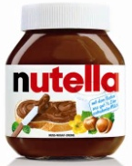

Brumby's Strathmore 3 Lloyd St, Strathmore 0393790056
#1 Hot Cross Bun Brumby's Store Australia / NZ, Store of the Year Australia and New Zealand, Australia - New Zealand Franchisee of the Year, Victorian Store of the Year Winner Victorian Retail of the Year Winner & Finalist Baking Team of the Year Winner & Finalist

Hot Cross Bun Fundraising Order Sheet

Brumby's Strathmore 2016

Name______________________ Ph ____________Class _______

For easy calculation = 1 = $7.50 2= $15 3 = $22.50 4 = $30 5= $37.50
Name | Quantity of Traditional (fruit)  Hot Cross Buns  (6 packs) | Quantity of Fruitless  Hot Cross Buns  (6 packs) | Quantity of Cadbury  Chocolate Chip  Hot Cross Buns  (6 packs) | Quantity of  Raspberry &  Cadbury  Chocolate  Hot Cross Buns  (6 packs) | Quantity of  Nutella Hot Cross Buns  (6 packs) | Total number of 6 packs

Total number of 6 packs ____________ x $7.50 ea

Total Price $______________

Order form and Payment Due back 15th March

Delivery and Pick up date: 21st March

Don't forget the class competition!

The winning class, with the most packs sold, will receive their very own

hot cross bun morning tea! YUM!!

